STORIES
Main page | Image | URL | Level / age | Topic / theme | Description | Useful for
MightyBook | 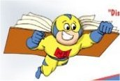 | http://www.mightybook.com/MightyBook_free/books/bobo_elephant/bobo.html

